**Pure Connect: A basic social media app with**

**news updates for IOS**

**Submitted By**

**Israt Tasnim Esha**

Roll: 1907090

**Jobair Al Nahian**

Roll: 1907071

**Hasib Hasan**

Roll: 1907089

**Sonjoy Roy**

Roll: 1907073

**Md. Safwan Zaher Asif**

Roll: 1907066



**Submitted To:**

Most. Kaniz Fatema Isha

Lecturer

Dept. of Computer Science and Engineering

Khulna University of Engineering & Technology

Argha Chandra Dhar

Lecturer

Dept. of Computer Science and Engineering

Khulna University of Engineering & Technology

1. Introduction

* 1. Background

Welcome to the magical world of Pokémon, where childhood dreams come alive and adventures await at every corner. Remember when you were captivated by Ash's journey, battling alongside Pikachu, and outsmarting Team Rocket? Now, your childhood fantasy becomes a reality with our new game, **Pokémon Battle**. Dive into a magical world where you become Ash, starting on a thrilling adventure to gather your Pokémon and engage in epic battles that will test your strategy and courage.

In this game, two players stand as the main contenders: **Ash,** the eternal hero, and **Team Rocket**, the mischievous challengers. Each player must assemble a team of three Pokémon to qualify for the ultimate showdown. Ash's loyal companions are **Pikachu**, the electrifying mouse; **Charmander**, the fiery lizard; and **Squirtle**, the water-splashing turtle. On the other side, Team Rocket brings their cunning **Meowth**, steadfast **Wobbuffet**, and smoky **Weezing**.

The journey begins with a dramatic twist: all Pokémon are undergoing health check-ups at three different **Pokémon Centers**. Players start with the location of the first center, but the next destinations are revealed by Nurse Joy only after reaching the first Pokémon. Each player travels in three different vans with limited fuel, racing against the clock to reach their Pokémon before the fuel runs out. Time and fuel are precious commodities—will they make it in time to qualify for the competition? After qualifying, the real battle begins. Each player receives an equal amount of coins to buy potions, crucial for healing their Pokémon during intense battles. This adventure is more than just a game; it's a race against time, a test of strategy, and a journey filled with excitement. Does the Pokémon Championship Adventure await—are Ash and Team Rocket ready for the challenge of a lifetime? The dream of becoming a Pokémon master is within reach!

The adventure isn't just about battles; it's about reliving those cherished moments of your childhood, where every corner of the Pokémon world held a new surprise, a new friend, and a new challenge. So, gear up, channel your inner Ash, and get ready to experience the Pokémon journey of your dreams.

* 1. Objectives and Goals:
* **Recreate the Magic:** Capture the wonder and excitement of the Pokémon series in a Python-based game.
* **Strategic Gameplay:** Implement strategic elements that allow players to choose and manage their Pokémon wisely.
* **Engaging Adventure**: Create a captivating adventure for Ash to retrieve his Pokémon, adding depth and excitement to the gameplay.
* **Epic Battles**: Simulate Pokémon battles with attack, defense, and elixir moves, bringing the thrill of the series to life.
* **Dynamic Swapping**: Allow players to swap Pokémon during battles, adding a layer of strategy and unpredictability.
* **Victory Conditions**: Define clear win/lose conditions based on the health status of all Pokémon, ensuring a fair and exciting competition.

**2. Methodology:**

**2.1 pokemon_find_screen.py**

* **Setup**
  + Randomly assign Ash, Team Rocket, and their respective Pokémon to different Pokémon centers and starting locations.
  + Ash knows the location of Pikachu, while Team Rocket knows the location of Meowth.
  + After Ash catches Pikachu, Nurse Joy provides the location of Charmander, followed by Squirtle. Team Rocket follows the same sequence with Meowth, Weezing, and Wobbuffet.
* **Mechanics**
  + Each player has a limit of 15 liters of fuel to catch each Pokémon and a total of 1 minute to catch all their Pokémon. A player is eliminated if they exceed the fuel limit or fail to catch all Pokémon within 1 minute.
  + Ash's movements are controlled by the player, while Team Rocket's movements are guided by an A* algorithm.

**2.2 elixir_screen.py**

* **Setup**
  + Each player is allocated the same amount of coins to purchase elixirs.
  + 5 elixirs have varying costs and power values.
* **Mechanics**
  + Players aim to collect elixirs with the highest power within their budget.
  + Ash selects elixirs with user assistance.
  + Team Rocket uses a genetic algorithm with tournament selection for optimal elixir collection.
  + Tournament selection picks the best-performing elixirs for each generation.
  + Final elixir collections are used in Pokémon battles to recover health points.

**2.3 play_screen.py**

* **Setup**
  + Each player has 3 Pokémon, each starting with 100 health points.
  + Battles are turn-based with two types of actions: attack and defense.
* **Mechanics**
* Pokémon and field types affect damage output:
* Type matches between Pokémon and field increase damage to opponent.
* Type advantages: Fire > Electric, Electric > Water, Water > Fire.
* Players can swap Pokémon if the health points of the swapped Pokémon are not 0.
* Elixirs can be used to boost health points.
* **Decision Making**
  + Ash takes user input for actions, elixir usage, and Pokémon swaps.
  + Team Rocket uses the minimax algorithm to choose actions.
  + Fuzzy logic helps Team Rocket decide when to use elixirs or swap Pokémon.

**2.4 UML Class diagram of the Implementation**

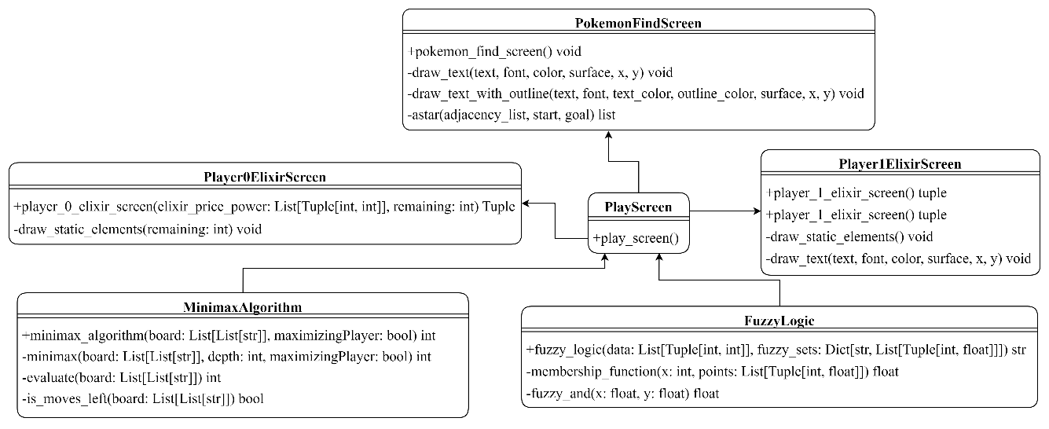

3. Result

In this section we will discuss about the features of our application and will add corresponding features:

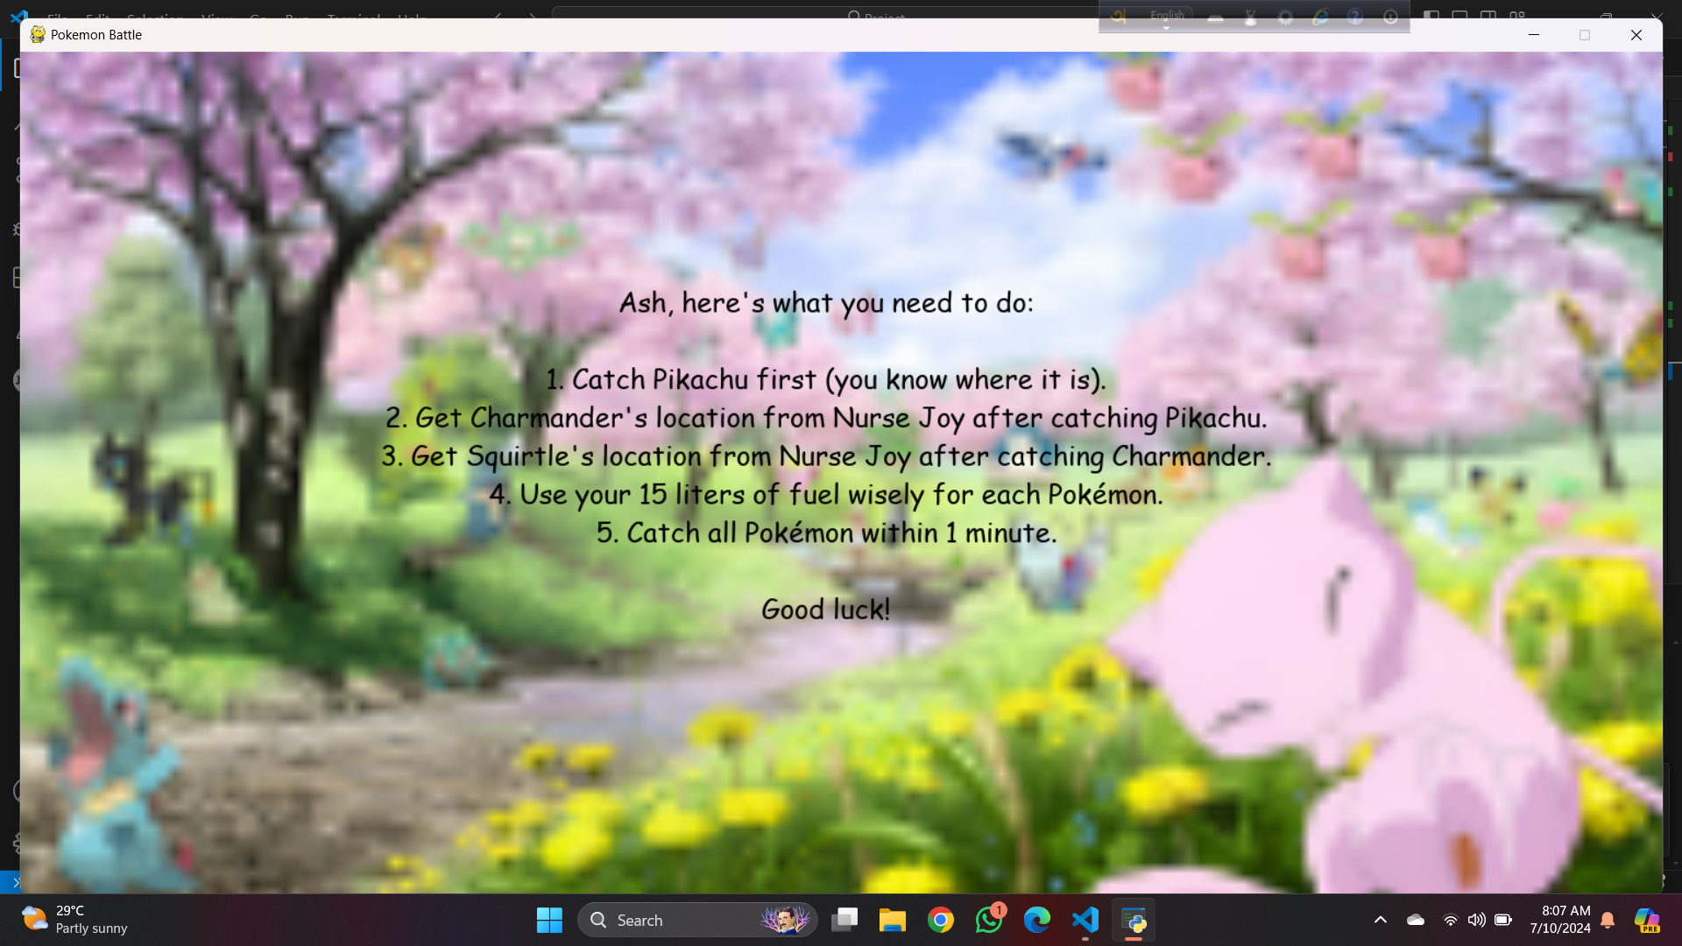

*Fig 3.1: announcement_screen.py (for pokemon_field_screen.py)*

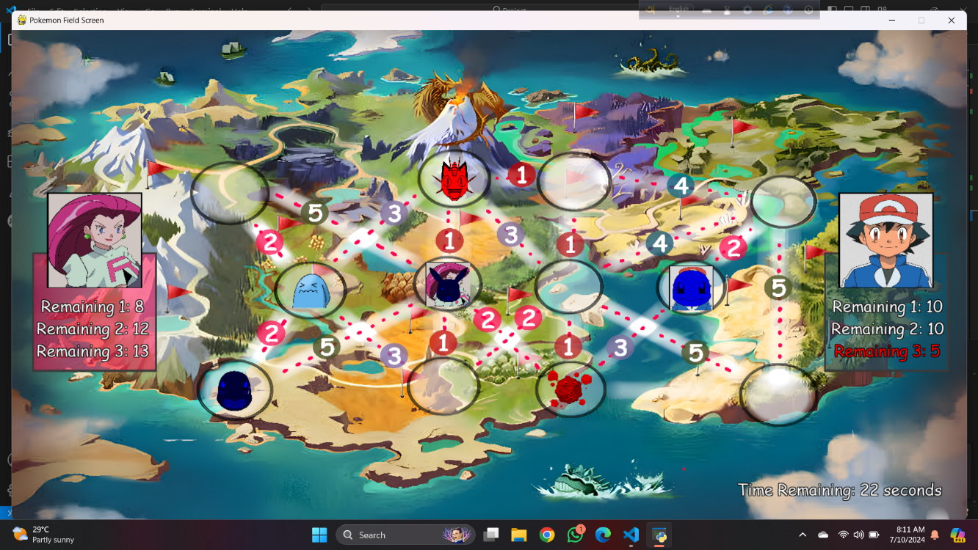

*Fig 3.2: pokemon_field_screen.py*

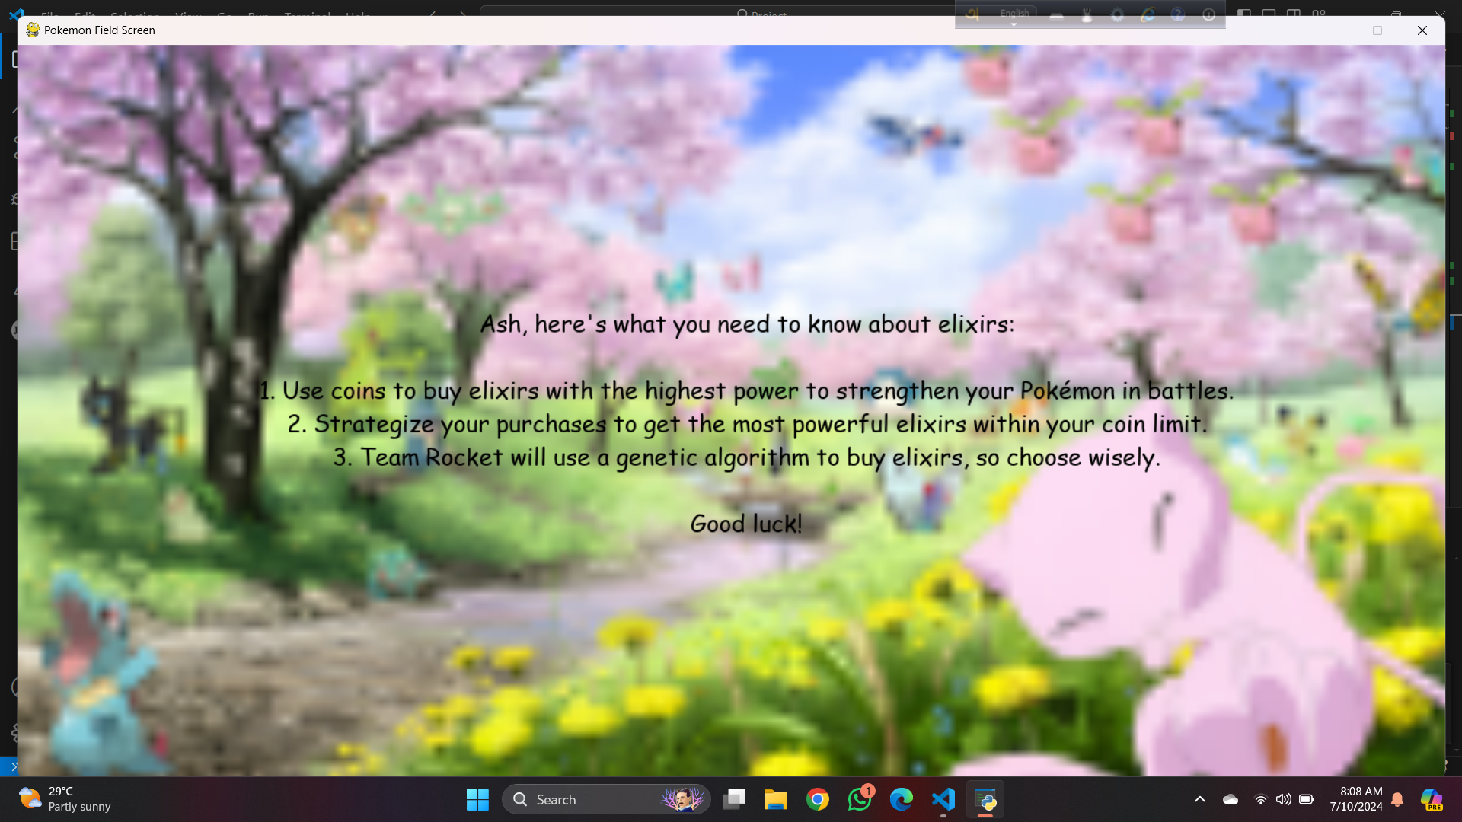

*Fig 3.3: announcement_screen.py (for player_1_elixir_screen.py)*

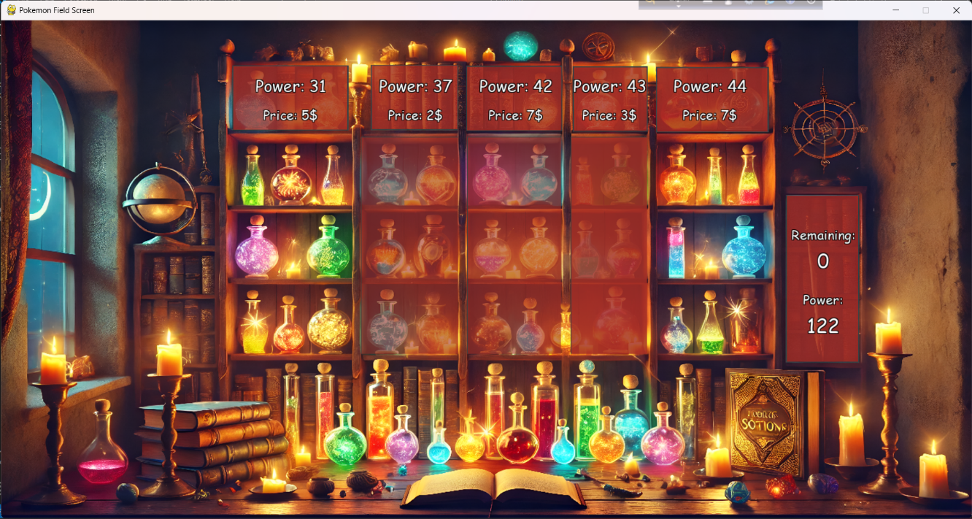

*Fig 3.4: player_1_elixir_screen.py*

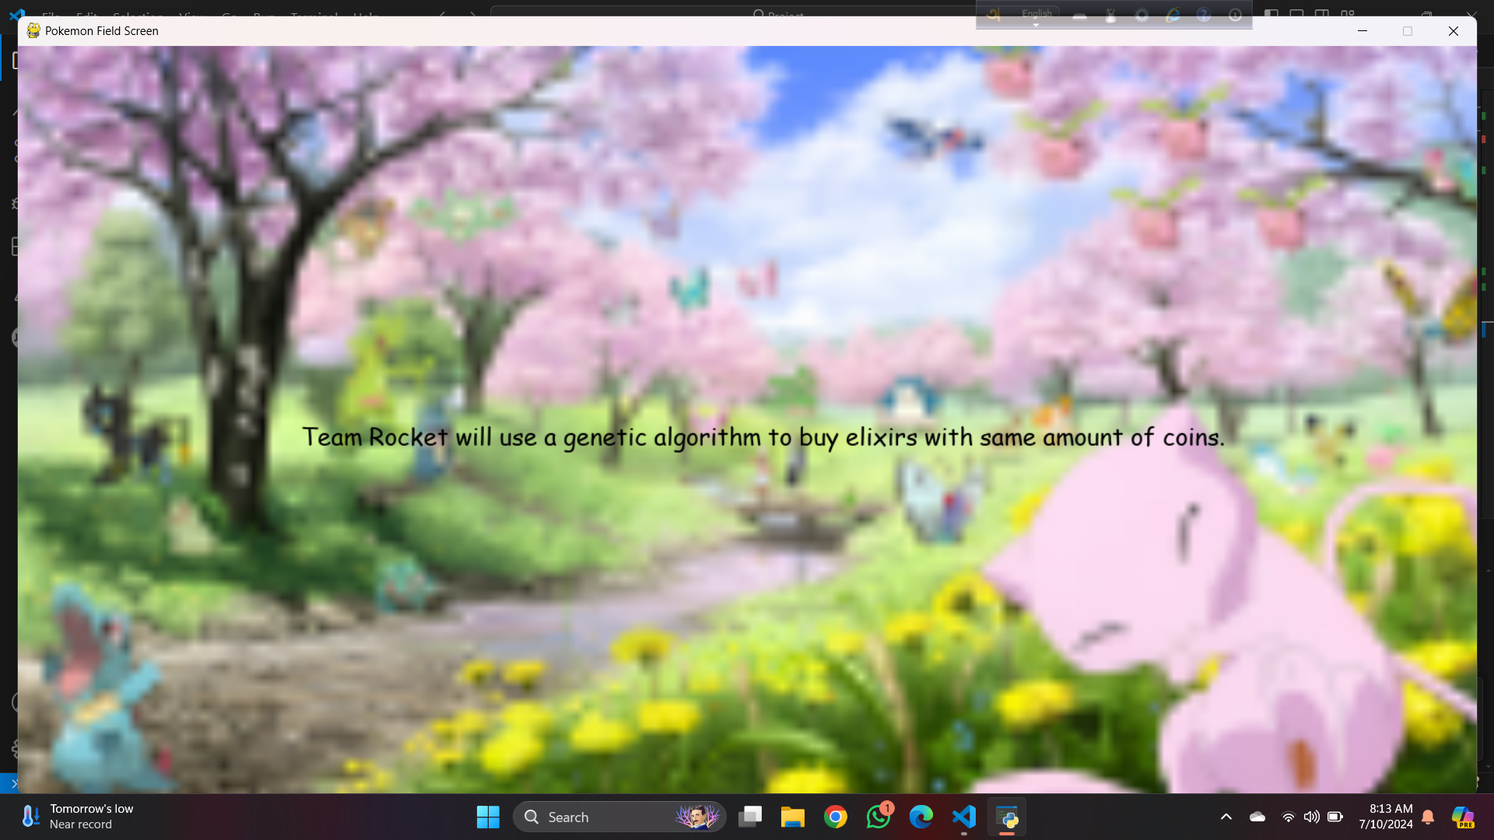

*Fig 3.5: announcement_screen.py (for player_0_elixir_screen.py)*

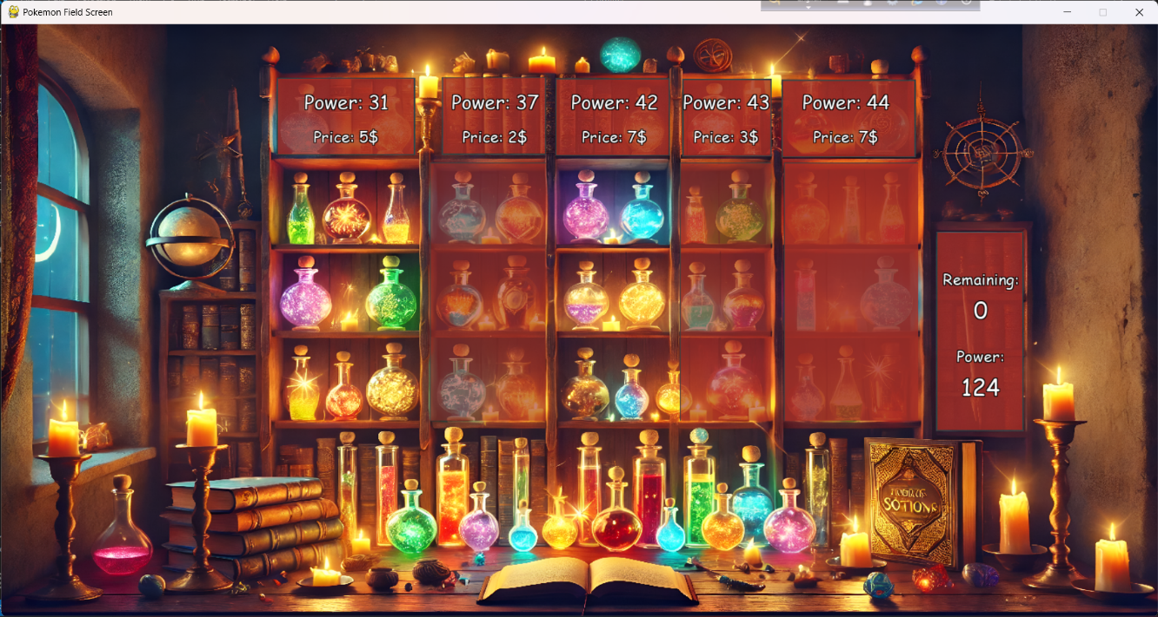

*Fig 3.6: player_0_elixir_screen.py*

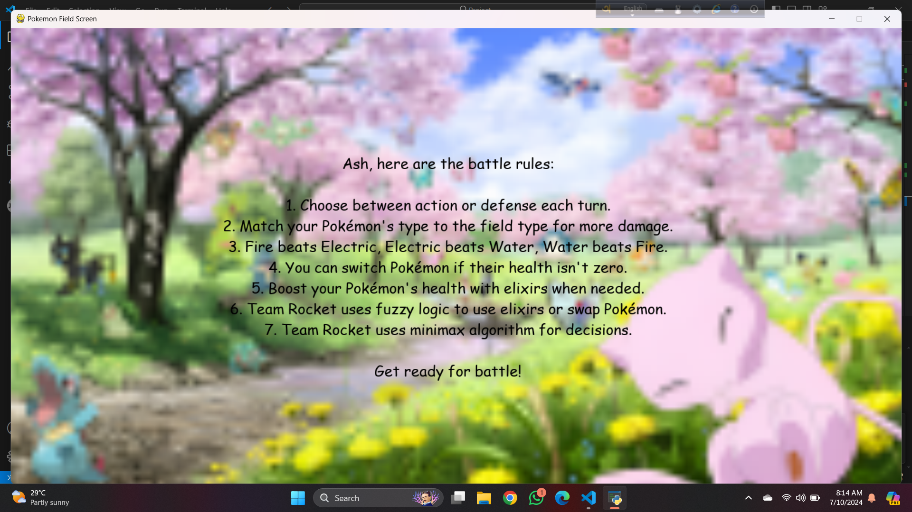

*Fig 3.7: announcement_screen.py (for play_screen.py)*

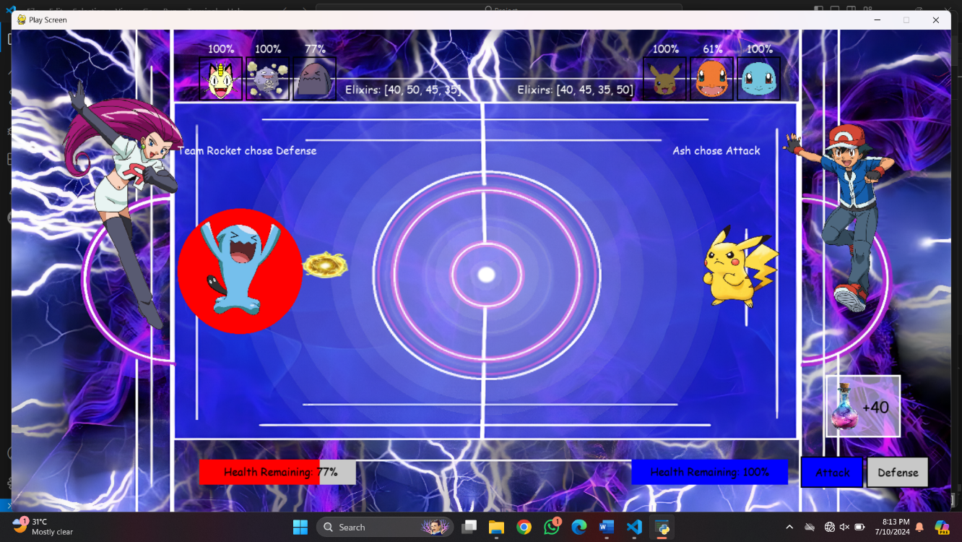

*Fig 3.8: play_screen.py (Electric Field, Team Rocket using defense, Ash using attack)*

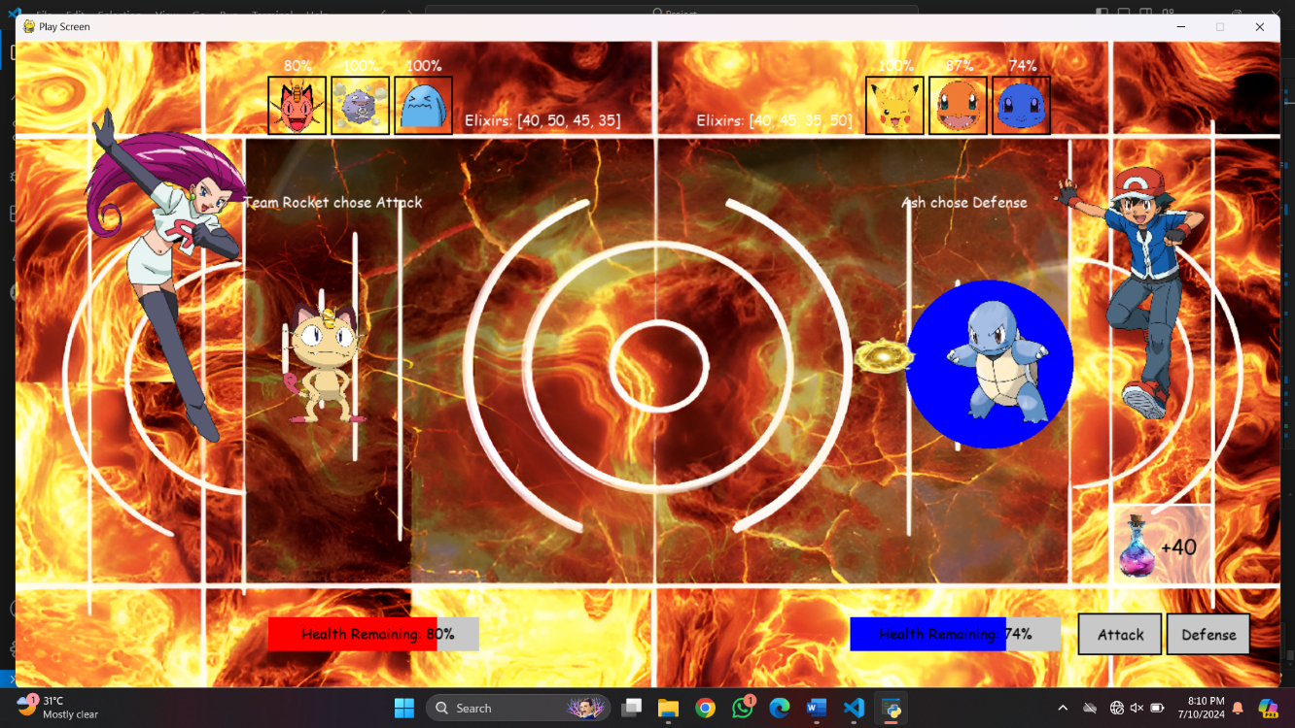

*Fig 3.9: play_screen.py (Fire Field, Team Rocket using attack, Ash using defense)*

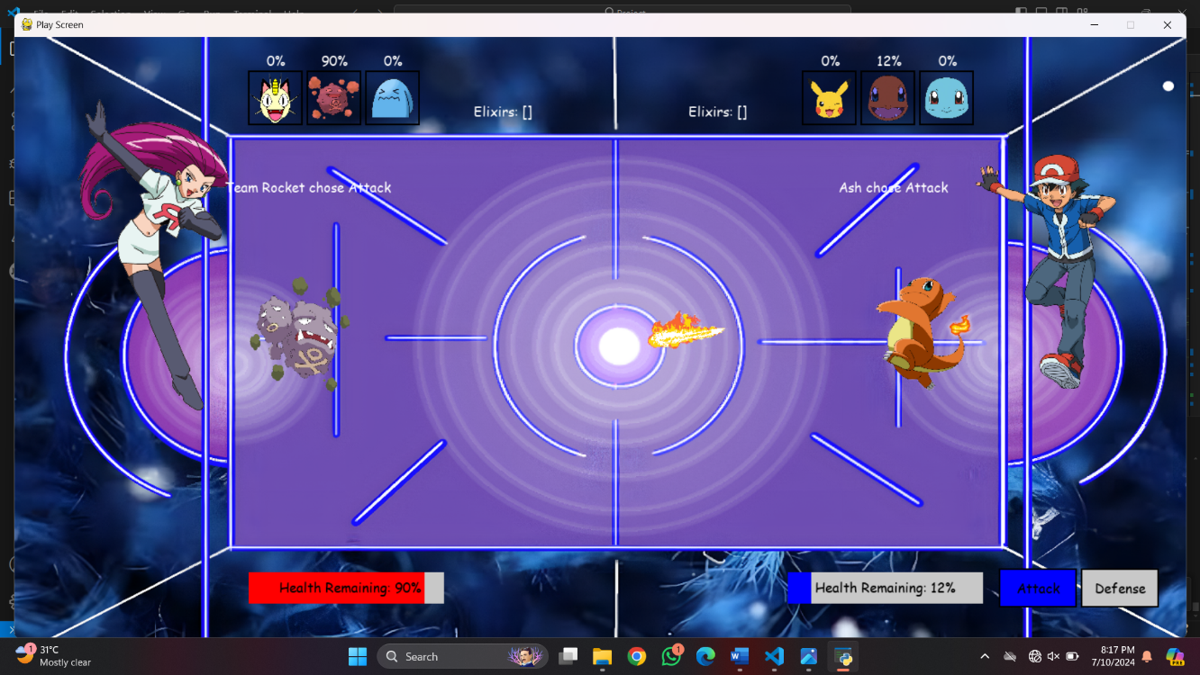

*Fig 3.10: play_screen.py (Water Field, Team Rocket using attack, Ash using attack)*

**4. Discussion:**

Developing Pure Connect had its challenges as we initially lacked our own Mac. However, we found creative solutions by using lab Macs and borrowing from our friends. Through collaboration and resourcefulness, we successfully completed the project. We could not add all the features that today’s Social Media app has. But with basic features Now, Pure Connect is ready for everyone to enjoy, thanks to the collective efforts of the team.

**5. Conclusion:**

We've made Pure Connect a friendly app where it's easy to share, connect, and stay updated. We aimed for a simple and enjoyable experience, and we're happy with what we've created. The app is all about bringing people together, sharing moments, and keeping everyone in the loop with what's happening.

**6. Future Plans:**

Looking ahead, we want to make Pure Connect even better:

* Make It More Intuitive: We're thinking of ways to make the app understand each user better, suggesting things they'd really like.
* Add More Features: We would try to bring messaging or groups, to make it even more fun and social.
* Keep the App Updated: Keeping an eye on new technologies. Maybe we'll try things like cool visual experiences or virtual reality to make using the app even more exciting.

**5. Reference:**

* [**https://developer.apple.com/documentation/uikit/uistoryboard**](https://developer.apple.com/documentation/uikit/uistoryboard)
* [**https://firebase.google.com/docs/ios/setup**](https://firebase.google.com/docs/ios/setup)
* **https://www.youtube.com/playlist?list=PLSzsOkUDsvdu5Mm67aBYs2YPu2OM4mFzt**